Pendle District Motor Club Ltd

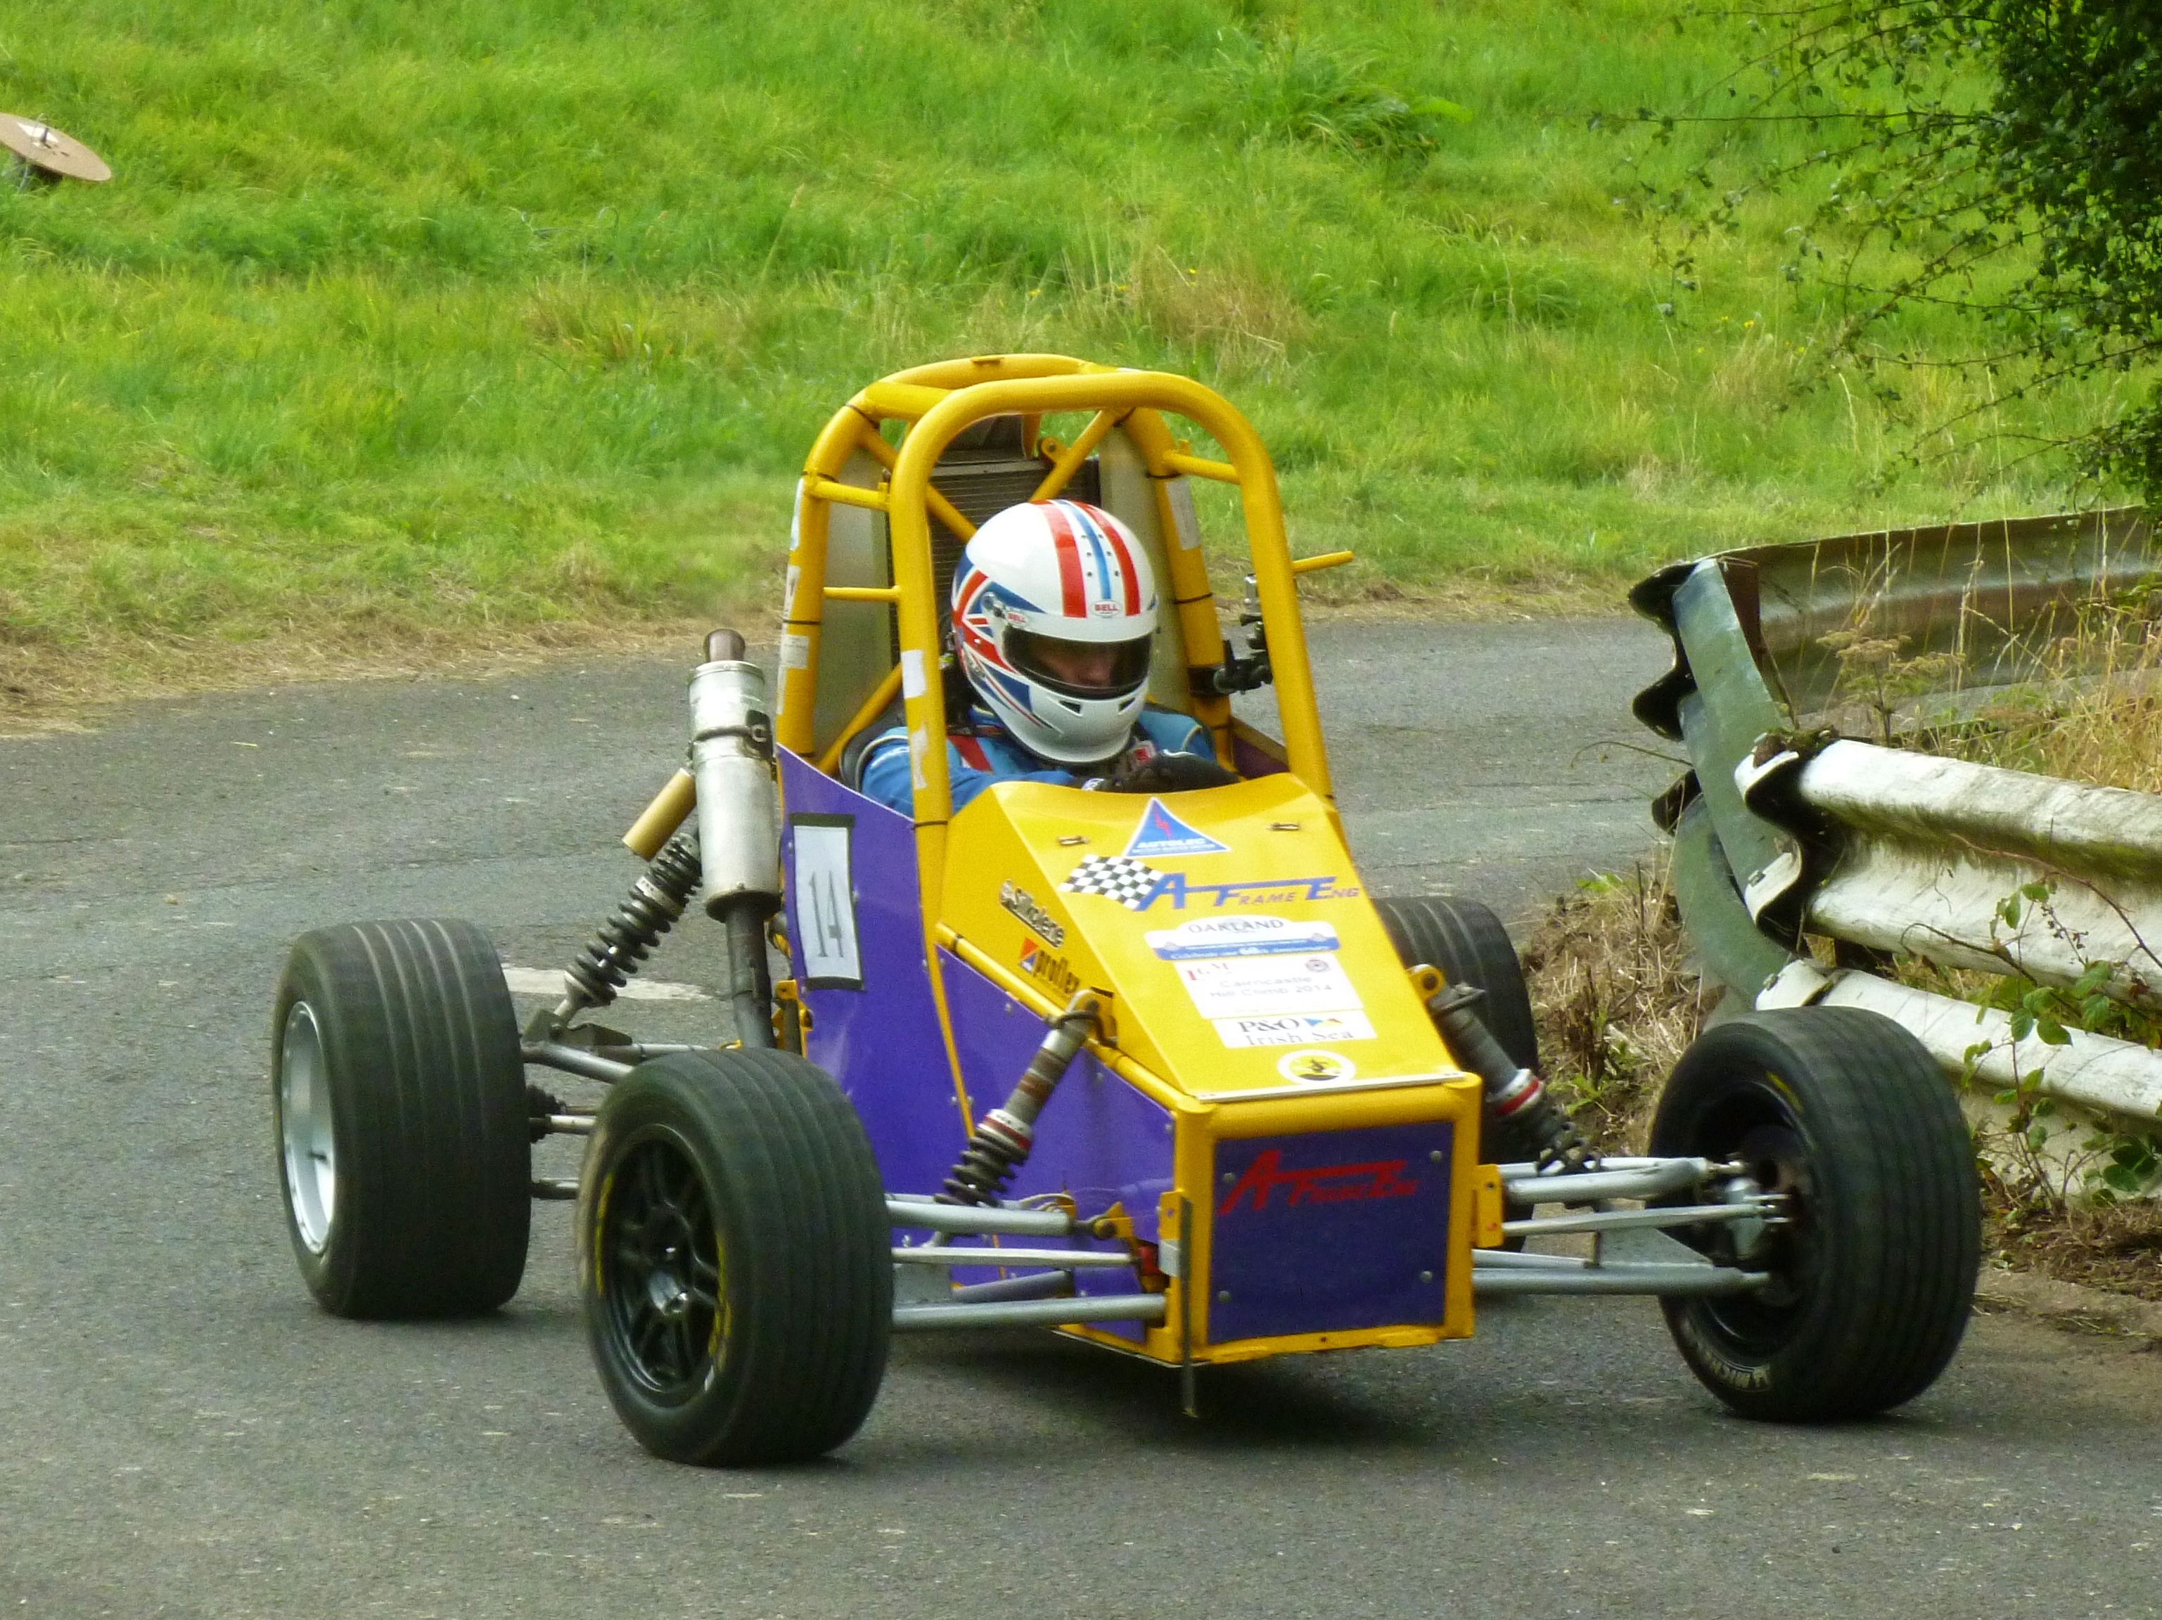

“August” Hill climb Scammonden

SATURDAY 12th August 2017

Round of the following Championships:
The 2017 Liverpool Motor club Championship
The 2017 Longton Motor Club Northern Speed Championship
The 2017 ANWCC Speed/Hillclimb/Sprint Championship.
The 2017 SD 34 MSG Sprint &HillclimbChampionship.
The 2017 Cross Border Speed Championship

Pendle District Motor Club Ltd

“August “Hill climb Scammonden

SATURDAY 12th August 2017

SUPPLEMENTARY REGULATIONS

1. The Pendle District Motor Club Ltd will organise a National B permit Hillclimb on 12th August 2016 at Scammonden
Dam

2. MSA permit Number: TBA

3. The event is open to (subject to written confirmation):-
a. All fully elected members of the organising club.
b. Members of the following clubs or championships listed in 4:-

4. The event is a round of the following Championships:
The Association of North Western Car Club Speed/Hillclimb/Sprint Championship.
SD 34 MSG Sprint&Hillclimb Championship.
The 2016 Liverpool Motor club Championship
Longton’s Northern Speed Championship
The 2017 Cross Border speed Championship

5. The programme of the event will be: - Scrutineering starts at 08:30hrs; Individual times for scrutineering will be
notified in Final Instructions. Any competitor not signed on by 1000hrs may be excluded. Practicing starts at
10:00hrs. Competitive timed runs may start immediately after the completion of practice at the discretion of the
organisers.

6. The length of the circuit is 550 yards and consists of smooth tarmacadam surface, with two left hand and two right
hand bends connected by straights.

7. The entry list opens on publication of the regulations and closes finally on Monday August 05th
the entry fee is £75 (including MSA insurance and per capita fee). All entries must be made online and accompanied by the appropriate fee
.
ONLINE LINK IS (entry Form):-

https://www.rallies.info/webentry/2017/scammondenaug/webentry.php

Cheques made payable to Pendle District Motor Club Ltd. please. Or BACS transfer to

HSBC Account number 81113011 Sort Code:- 40-09-11
Please put the drivers name down in the reference field.HSBC Account name PENDLE DISTRICT MOTOR CLUB LTD

PLEASE NOTE THAT AN INSURANCE CLAIM CAUSED/RAISED BY A COMPETITOR CARRIES AN AUTOMATIC £350 EXCESS PAYABLE BY THE COMPETITOR

8. The maximum entry for the meeting is 45, the minimum is 30. The minimum in each class is 3. Should any of these
figures not be reached, the organisers have the right to either cancel the meeting or amalgamate classes as
necessary. Entries will be selected by date of receipt. Entry fees may be refunded subject to notification to the
secretary prior to the closing date and will be subject to a £5.00 administration charge.
The club reserves the right to pass on to the competitor concerned any bank charges incurred by those cheques, which
do not clear at the first presentation. Refunds after the closing date will be at the discretion of the organisers.

9. The entries secretary to whom all entries and completed labels must be sent is
Rodney Brereton, 2 Parkside, Sough, Barnoldswick, Lancashire, BB18 6TA (01282 843297 not after 9:00pm PLEASE)
Note that entries will only be acknowledged if a Stamp Self-Addressed Envelope is provided or a valid email address.

10. Other officials are:
MSA Steward: TBA;
Club Stewards: Ray Duckworth & tba.
Clerk of the Course: Rodney Brereton
Chief Scrutineer: Chris Mansley
Chief M.O.: T.B.A.
Rescue Unit: - Richard Ashton /Calder Rescue
Secretary of the Meeting: Rodney Brereton
Chief Timekeeper: David Clay
Chief Marshal: - Barry Wilkinson Mobile (Before 9:00pm please) + 447711791631 email :- blu161@gmail.com
Deputy Chief Marshal: - Peter Wilkinson

11. The meeting will be held under the General Regulations of the MSA Ltd. (incorporating the provisions of the
International Sporting Code of the FIA) and these Supplementary Regulations.
12 Awards will be presented:
FTD – An award
1st in Class – An award
2nd in Class – An award – Subject to 4 entries
3rd in Class – An award - Subject to 7 entries

Additional awards will also be presented thus: - ANY one make car or motor club furnishing 5 or more entries will be
eligible for best of that club/make.

13. All competitors and drivers must hold and present a valid Competition License plus a valid Club Membership Card
or Championship Registration Card (as appropriate).

14. Provisional results will be published as soon as possible following the end of the event and mailed to all
competitors within 7 days.

15. Any protest must be lodged in accordance with C5.1.2.

16. The event will consist of at least the classes described in the Technical Regulations contained in these
regulations.

17. Starting order will be determined by classes. Cars will start singly. The starting signal will be a green light.
Method of timing will be by automatic split beam apparatus. The finish line will be indicated by a white line and
chequered boards at the side of the track.

18. Competitors will have the opportunity of two practice runs. Competitors will have the opportunity to walk the
course prior to the first practice run under official control.

19. There will be a minimum of two and a maximum of EIGHT timed runs. Subject to weather and conditions. The Final
number of TIMED runs will be declared after practicing has finished.

20. Competitors will be identified with numbers which will NOT be provided by the organisers.

21. Marking and penalties will be as printed in the appropriate section of the MSA general regulations, in addition,
a) All four wheels off the tarmac surface - no time will be recorded.

All other General Regulations apply as written except for the following which are modified:-

S9.2.3 A driver may not compete in more than two cars during the event.
All cars competing in Hill climbs and Sprints must be presented for scrutineering with a valid MSA Competition Log
Book or an MSA recognised vehicle identity document unless the car is currently licensed for use on the public
highway and competing in the event in a road legal condition (S9.1.7). PLEASE REFER TO THE 2017 TECHNICAL REGULATIONSFOR THE EVENT, IN ADDITION TO THE CLASSES LISTED IN THE TECHNICAL REGULATIONS ACCEPTED CHAMPIONSHIP CLASSES WILL ALSOBE INCLUDED

Unseeded/seeded entry list is here
https://www.rallies.info/webentry/2017/scammondenaug/entries.php?type=u

2017 NORTH & MIDLAND SPEED RECOMMENDED CLASSES

Road-going Series Production Cars: (S11)

You must be able to produce a current Tax Disc, Insurance and MOT certificate, where applicable, at Scrutineering.
Proof of Road Tax will be via DVLA confirmation of Vehicle Tax or a recent copy of the DVLA enquiry website.
(www.vehiclesenquiry.service.gov.uk) Classes SA to SC & 1A to 1C must use 2017 List 1A, tyres, classes 1D to 1G & 2A to 2D may use 2017 MSA list 1B tyres, all tyres must comply with (L2.3)
For classes SA, SB & SC, the forced induction equivalence is 1.7 (S11.9.1.4)
SA: Standard Saloon Cars up to 1400cc
SB: Standard Saloon Cars over 1400cc up to 2000cc
SC: Standard Sports Cars up to 2000c
1A: Saloon Cars up to 1400cc
1B: Saloon Cars over 1400cc up to 2000cc
1C: Saloon Cars over 2000cc
1D: 2 & 4 Seater Sportscars up to 2000cc
1E: 2 & 4 Seater Sportscars over 2000cc
1F: Road going saloon cars that are not eligible for any of the above classes
1G: Road –going Lotus Elise and other non-ferrous chassis construction Cars up to 2200cc
For classes SA, SB & SC, The forced induction equivalence is 1.7 (S 11.9.1.4)

Road-going Specialist Cars: (S11)

2A: Road-going Kit, Replica & Space framed Cars up to 1700cc (car derived engines)
2B: Road-going Kit, Replica & Space framed Cars over 1700c (car derived engines)
2C: Road-going Kit, Replica & Space framed Cars (motorcycle derived engines)
2D: Road-going Specialist Cars that are not eligible for classes 2A, 2B, 2C.

Modified Series Production Cars: (S12)

3A: Saloon Cars up to 1400cc
3B: Saloon Cars over 1400cc. up to 2000cc
3C: Saloon Cars over 2000cc
3D: 2 & 4 Seater Sportscars up to 2000cc
3E: 2 & 4 Seater Sportscars over 2000cc

Modified Specialist Production Cars (S12)

3F: Modified Kit, Replica & Space framed Cars up to 1700cc (car derived engines)
3G: Modified Kit, Replica & Space framed Cars over 1700cc (car derived engines)
3H: Modified Kit, Replica & Space framed Cars (motorcycle derived engines)
3K: All Modified Specialist Cars that are not eligible for classes 3F, 3G or 3H

Sports Libre & Hillclimb Super Sports Cars: (S13, S14)

4A: Cars up to 2000cc & Hillclimb Super Sport
4B: Cars over 2000cc

Racing Cars: (S15)

5A: Up to 1100cc
5B: Formula Ford 1600 Racing Cars manufactured before 1 January 1994
5C: Cars over 1100cc up to 1600cc
5D: Cars over 1600cc up to 2000cc
5E: Cars over 2000cc
Class E : Electrically powered cars (excluding hybrids)
Extra classes for Classics, single makes & Championships etc can be added as required

In addition the following special classes are included:
Class R1 – Rally cars up to 1600cc
Class R2 – Rally cars over 1600cc
Class S1 – Pre-war Austin Seven Road cars
Class S2 – Pre-war Austin Seven Track cars

All vehicles must comply with MSA Technical Regulations and with the specific regulations for each category/class as specified in S10. See the 2017 MSA Yearbook Section B for the definition of a Sports Car.
(All classes) Cars shall have a towing point of adequate strength at both front & rear, clearly marked by an arrow and the word “Tow” using a contrasting colour. A suitable point on the roll hoop will generally suffice for open single seater and open sports racing cars.
Equivalence factors are as per, S10.3.1, S10.3.2, S11.9.1.4
The requirements of the current MSA regulations with regards to safety provisions for Sprint and Hillclimb cars must be adhered to.

Clarifications for Road-going Series Production Cars
All cars must have current UK road tax. Proof will be via DVLA Confirmation of Vehicle Tax or a recent copy of the DVLA enquiry website (www.vehicleenquiry.service.gov.uk/), a current MOT if age requires it, & insurance. It is the driver’s responsibility to prove compliance.
All road-going cars must remain in a totally road-legal condition at all times. (S11.2)
Classes SA, SB & SC only: Trade plates and traders or company group insurance policies will not be accepted. S11.9.1.2
All other Road-going Series Cars are as S11.2.
Classes SA, SB & SC
These classes are intended to attract new inexperienced drivers, using cars with very few modifications (as listed), to encourage low-cost entry into the sport. All cars running in the above classes must remain in totally road legal form at all times.
NO modifications (optional or otherwise) are permitted which are likely to improve the performance and handling of the car which must also comply with the following:
All other regulations are as per S11.9 2017 MSA Year Book
Any modifications not specifically permitted are, by definition, not allowed.
* “Standard” means components that were listed in the manufacturer’s price list for that model of car.
Classes 1A to 1G
Tyres: Classes 1A to 1C must use Tyres from the 2017 MSA List 1A; classes 1D to 1G may use tyres from the 2017 MSA List 1B.
Exhaust systems; all petrol engined cars manufactured after 31st Dec 1999 must include a working catalytic converter.
Brakes; Brake calipers, discs, master cylinder, shoes& pads can be modified. Carbon discs are not permitted. Modification of the brake pedal is permitted. Brake bias adjustment is allowed. (Brake balance adjusters must not be available for adjustment during running. 2017 MSA Year Book S10.7.2). The fitting of aftermarket pedal assemblies is not permitted.
Anti-Lock braking systems can be removed but cannot be added to a vehicle that does not have one as a manufacturer specified option.
Suspension; (As per S11)
Non-adjustable Strut Braces across the top of the front suspension turrets are allowed but these must be removable and not welded in place.
Safety; Pyrotechnic safety devices such as airbags and seatbelt pretensioners may be disconnected or removed.
Classes 2A to 2D
As per S11
All other classes are as specified in Section S
Please Note: Scrutineers and Championship Officials reserve the right to check all road-going competition vehicles’ taxation status via the DVLA website to ensure compliance with championship regulations.
It is the competitor’s responsibility to ensure that all data held by the DVLA is accurate for the vehicle being entered into competition.

