Pendle District Motor Club Ltd

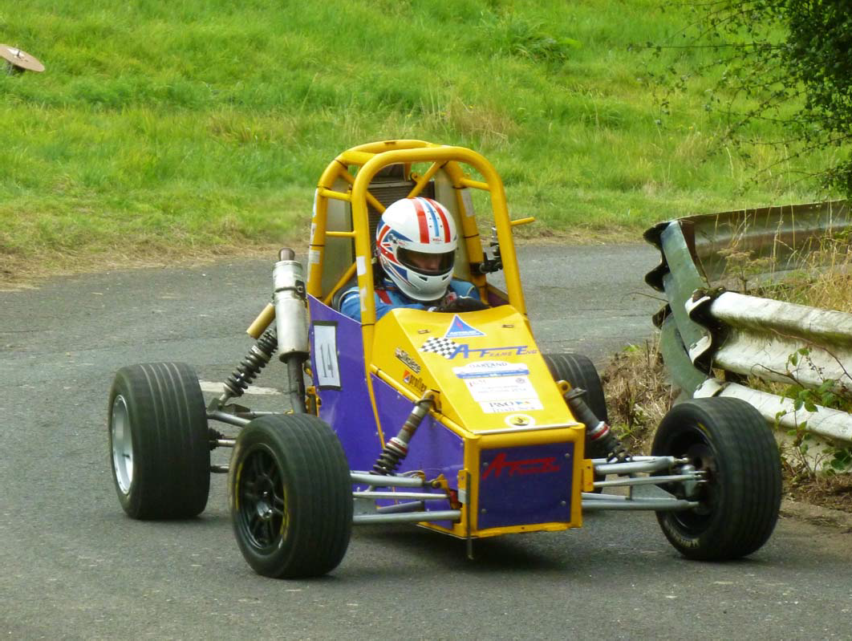

“Rod Brereton” Hill climb
SUNDAY 13 September 2026
Round of the following Championships: The 2026 Liverpool Motor club Championship
The 2026 Longton Motor Club Northern Speed Championship The 2026 ANWCC Speed/Hillclimb/Sprint Championship.
ANWCC With SD34 Hillclimb Championship.
The 2026 Cross Border Speed Championship
The 2026 Sheffield & Hallamshire Championship

Pendle District Motor Club Ltd “
Rod Brereton “Hill climb Scammonden” SUNDAY 13th September 2026

SUPPLEMENTARY REGULATIONS

- The Pendle District Motor Club Ltd will organise an INTERCLUB Permit Hillclimb on Sunday 13th September 2026 at Scammonden Dam

- MSUK permit Number: TBC`

- The event is open to (subject to written confirmation):-
  - All fully elected members of the organising club.
  - Members of the following clubs or championships listed in 4:-
- The event is a round of the following Championships:
The Association of North Western Car Club Speed/Hillclimb/Sprint Championship. SD 34 MSG Sprint & Hillclimb Championship.
The 2026 Liverpool Motor club Championship Longton’s Northern Speed Championship
Sheffield & Hallamshire Championship

- The programme of the event will be: - Scrutineering starts at 08:30hrs; Individual times for scrutineering will be notified in Final Instructions. Any competitor not signed on by 1000hrs may be excluded. Practicing starts at 09:45hrs Competitive timed runs may start immediately after the completion of practice at the discretion of the Organisers.

- The length of the circuit is 550 yards and consists of smooth tarmacadam surface, with two left hand and two right hand bends connected by straights.

- The entry list opens on publication of the regulations and closes finally on Monday 7th September 2026
the entry fee is £110 (including MSA insurance and per capita fee). All entries must be made online and accompanied by the appropriate fee
.
ONLINE LINK IS (entry Form):- Awaiting

ENTRIES ACCEPTED BY BACS TRANSFER ONLY
HSBC Account number 81113011 Sort Code:- 40-09-11
Please put the drivers name down in the reference field.HSBC Account name PENDLE DISTRICT MOTOR CLUB LTD

PLEASE NOTE THAT AN INSURANCE CLAIM CAUSED/RAISED BY A COMPETITOR CARRIES AN AUTOMATIC
£350 EXCESS PAYABLE BY THE COMPETITOR

- The maximum entry for the meeting is 45, the minimum is 30. The minimum in each class is 3. Should any of these figures not be reached, the organisers have the right to either cancel the meeting or amalgamate classes as necessary. Entries will be selected by date of receipt. Entry fees may be refunded subject to notification to the secretary prior to the closing date and will be subject to a £5.00 administration charge.

- The entries secretary is
Andy Rushton
Email ar68@btinternet.com

- Other officials are:
MSA Steward: TBA ;
Club Stewards: Ray Duckworth.
Clerk of the Course: Graham Keen
Chief Scrutineer: TBA
Chief M.O.: TBA
Rescue Unit: - Calder Rescue
Secretary of the Meeting: Chris Andrew
Chief Timekeeper: Chris Winstanley (TIME TEAM TIMING)
Chief Marshal: - Barry Wilkinson Mobile (Before 9:00pm please) + 447711791631 email :- blu161@gmail.com Paddock Marshal :- TBC

- The meeting will be held under the General Regulations of the MSA Ltd. (incorporating the provisions of the International Sporting Code of the FIA) and these Supplementary Regulations.
12 Awards will be presented:
FTD – An award
1st in Class – An award
2nd in Class – An award – Subject to 4 entries 3rd in Class – An award - Subject to 7 entries

Additional awards will also be presented thus: - ANY one make car or motor club furnishing 5 or more entries will be eligible for best of that club/make.

- All competitors and drivers must hold and present a valid Competition License plus a valid Club Membership Card or Championship Registration Card (as appropriate).

13 ALL refuelling must take place over an impervious membrane

- Provisional results will be published as soon as possible following the end of the event and electronically sent to all Competitors within 7 days. Additionally it is intended to provide live timing of the event via the internet using Time Team’s website visit:: www.timeteamlivetiming.co.uk or scan the QR code below:

www.timeteamlivetiming.co.uk

- Any protest must be lodged in accordance with NCR Ch2 App 9 Art 1

- The event will consist of at least the classes described in the Technical Regulations contained in these Regulations.

- Starting order will be determined by classes. Cars will start singly. The starting signal will be a green light. Method of timing will be by automatic split beam apparatus. The finish line will be indicated by a white line and checkered boards at the side of the track.

- Competitors will have the opportunity of two practice runs. Competitors will have the opportunity to walk the
course prior to the first practice run under official control.

- There will be a minimum of two and a maximum of twelve timed runs. Subject to weather and conditions.

- Competitors will be identified with numbers which will NOT be provided by the organisers.

Shared vehicles are permitted as long as two entries for the same vehicle are submitted. No more than two entries per vehicle are permitted
22 Marking and penalties will be as NCR Ch14 App3 Art 3.4, in addition ,all four wheels off the tarmac surface –no time will be recorded

All other General Regulations apply as written except for the following which are modified:-

All other General Regulations apply as written except for the following which are modified: -
NCR Ch14 App2 Art 5.1, A driver may not compete in more than two cars during the event

NCR Ch14 App1 Art 4.1, All Vehicles competing in Hill Climbs or Sprints must be presented for scrutineering with a valid Competition Car Log Book / Vehicle Passport or an ASN Recognised Vehicle Identity Document
unless the Vehicle is currently licensed for use on the Public Highway and is competing in a road legal
condition

Signing-on is by completing the online declaration on your entry page at Rallies.info.

There is no on line scrutineering, however on line signing on is required and licences will be checked on the day.

An unseeded/seeded entry will be available on the Rallies Info web site.

PLEASE NOTE:- All the three clubs, who run events at the venue have pooled together and have received a matching offer, from MSAUK thanks to sterling efforts from Richard Stephens,to repair the “hill” to ensure we get continued events and it does not end up not being fit for purpose

2026 NORTH & MIDLAND SPEED RECOMMENDED CLASSES

Classes
All cars must comply with NCR 14 (GR Section S).
You must be able to produce proof of current UK Road Tax (and MOT where applicable) at the event if competing in one of the Standard or Road Car classes. Proof of Road Tax will be via DVLA Confirmation of Vehicle Tax or a recent copy of the DVLA enquiry website: www.vehicleenquiry.service.gov.uk.
Cars in the Standard Car Classes must use tyres from List 1A in the current Motorsport UK NCR’s, all other Road Car classes must use tyres from List 1A or 1B. All tyres must comply with NCR Ch.8.4 (GR L2.3).
The forced induction equivalence for the Standard Car Classes is 1.7, for all other classes it is 1.4 – NCR 14.4.4.1 (GR S10.4.1). For rotary engines see NCR 14.4.4.2 (GR S10.4.2).
Times recorded by drivers in the Intro-Class will not count towards any championship.

Standard Cars conforming to NCR 14.4.13 (GR S11):
Junior: Standard cars with drivers aged 14 to 16 inclusive, complying with NCR 14.2.1.9-10 (GR S7.1.9)
Intro: Intro-Class – Standard cars & drivers complying with NCR 14.2.1.12 (GR S11.1.3)
SA: Standard Saloon Cars up to and including 1400cc
SB: Standard Saloon Cars over 1400cc up to and including 1700cc
SC: Standard Saloon Cars over 1700cc up to and including 2000cc
SD: Standard Sports Cars up to and including 2000cc
See NCR Ch1 App1 (1.1) for definitions of Saloon Cars & Sports Cars
Road Cars - Series Production Cars conforming to NCR 14.4.14 (GR S12):
1A: Saloon Cars up to and including 1400cc
1B: Saloon Cars over 1400cc up to and including 2000cc
1C: Saloon Cars over 2000cc
1D: 2 & 4 Seater Sportscars up to and including 2000cc
1E: 2 & 4 Seater Sportscars over 2000cc
1F: Lotus Elise and other non-ferrous chassis cars up to and including 2200cc
1G: Lotus Elise and other non-ferrous chassis cars over 2200cc
Road Cars - Specialist Production Cars conforming to NCR 14.4.14 (GR S12):
2A: Kit, Replica & Spaceframed Cars up to and including 1800cc (car derived engines)
2B: Kit, Replica & Spaceframed Cars over 1800cc (car derived engines)
2C: Kit, Replica & Spaceframed Cars (motorcycle derived engines)
2D: Specialist Production Cars that are not eligible for Classes 2A, 2B or 2C
Modified Cars - Series Production Cars conforming to NCR 14.4.15 (GR S13):
3A: Modified Saloon Cars up to and including 1400cc
3B: Modified Saloon Cars over 1400cc up to and including 2000cc
3C: Modified Saloon Cars over 2000cc
3D: Modified 2 & 4 Seater Sportscars up to and including 2000cc
3E: Modified 2 & 4 Seater Sportscars over 2000cc
Modified Cars - Specialist Production Cars conforming to NCR 14.4.15 (GR S13):
3F: Modified Kit, Replica & Spaceframed Cars up to and including1800cc (car derived engines)
3G: Modified Kit, Replica & Spaceframed Cars over 1800cc (car derived engines)
3H: Modified Kit, Replica & Spaceframed Cars (motorcycle derived engines)
3K: Modified Cars that are not eligible for Classes 3A to 3H
Sports Libre Cars conforming to NCR 14.4.16 (GR S14):
4A: Cars up to and including 2000cc
4B: Cars over 2000cc
Racing Cars conforming to NCR 14.4.17 (GR S15):
5A: Up to and including 1100cc
5B: Formula Ford 1600 Racing Cars manufactured before 1st January 1994
5C: Cars over 1100cc up to and including 1600cc
5D: Cars over 1600cc up to and including 2000cc
5E: Cars over 2000cc
Suggested titles for optional classes:
Other classes conforming to NCR 14 Ch13 App4 Art 13:
6A: Classic Road Cars manufactured 1962 to 1995 (inclusive)
6B: Classic Racing Cars manufactured 1961 to 1995 (inclusive)
6C: Pre-war Austin 7’s
6D: Period-defined (A-E) road cars (built before 1962)
6E: Period-defined (A-E) racing cars (built before 1961)
7R: Rally Cars conforming to NCR14 Ch15 App4 Art 17
(Further classes can be added by organisers as required)

All vehicles must comply with Motorsport UK Technical Regulations and with the specific regulations for each category/class as specified in NCR 14 Ch1 (App1 -App1.10) .

The requirements of the current Motorsport UK regulations with regard to safety provisions for Sprint and Hillclimb Cars must be adhered to ,including the use of suitable Frontal Head Restraints where mandatory

Clarifications for Road-going Series Production Cars

All cars must have current UK road tax. Proof will be via DVLA Confirmation of Vehicle Tax or a recent copy of the DVLA enquiry website (www.vehicleenquiry.service.gov.uk/), a current MOT if age requires it, & insurance. It is the driver’s responsibility to prove compliance.

Standard Car Classes ~ Standard Cars conforming to NCR 14 Ch13 App4 Art 13
These classes are intended to provide low budget competition for newcomers to the sport or those with limited funds. Other than adding FIA/Motorsport UK approved/homologated safety equipment and/or fitting uprated brake friction material, no other modifications are allowed. Any replacement component fitted must be a *Standard Part or a Standard Pattern Part.
Restricted to 2-wheel drive cars produced since 1st Jan 2000, minimum production 5000 per annum.
Engine: Maximum capacity 2000cc (1400cc for Junior drivers), forced induction equivalency is 1.7.
Junior drivers must also comply with NCR Ch14 App2 Art 2
Wheels and tyres: Standard wheels, and list 1A tyres only, complying with NCR14 Ch14 App6 Refer To (Ch8 App4 List1A)
Standard mHEV’s (as defined in NCR Ch7 App11 Art1.9 with all electrical equipment operating at less than 60vDC or 30vAC may enter the Standard Car classes, subject to the 1.7 forced induction equivalency where applicable.
* “Standard” means a component that was listed in the car manufacturer’s price list for that model of car
Classes 1A to 1G and 2A to 2D - Road Cars conforming to NCR14 Ch14 Art 1-8
Tyres: Tyres must be from List 1A or 1B complying with NCR14 Ch14 App6 Art1 Refer to (Ch8 App4 List 1A).
Suspension: Must comply with NCR14 Ch14 App7 Art 1-7. Strut Braces across the top of the front suspension turrets are allowed but these must be removable and not welded in place.
Safety: Pyrotechnic safety devices such as airbags and seatbelt pre-tensioners may be disconnected or removed.

Cars competing in road legal condition

Please Note: Scrutineers and Championship Officials reserve the right to check all road-going competition vehicles’ taxation status via the DVLA website to ensure compliance with championship regulations. It is the competitor’s responsibility to ensure that all data held by the DVLA is accurate for the vehicle being entered into competition. https;//www.rallies.info/webentry/home

Class 5B : Formula Ford 1600 Racing Cars : Manufactured before 1st January 1994 Only full sets of the following tyres are to be used :-

Cars manufactured before 31.12.1971 :- Cooper/Avon Formula Ford specification ACB9 or Dunlop historic Formula Ford Tyres
Cars manufactured 1.11972 to 31.12.1993:- Cooper/Avon Formula Ford specification ACB9 or ACB10 Tyres. All road- going cars must remain in a totally road-legal condition at all times

Classes 6 & 7: Classic Cars and Rally Cars.
All cars must comply with NCR 14 Ch15. Where there is conflict between regulations, those in NCR 14 Ch14 App1 Art7 refer to App4 Art15 will apply.

All other Technical regulations are as specified in Section S

